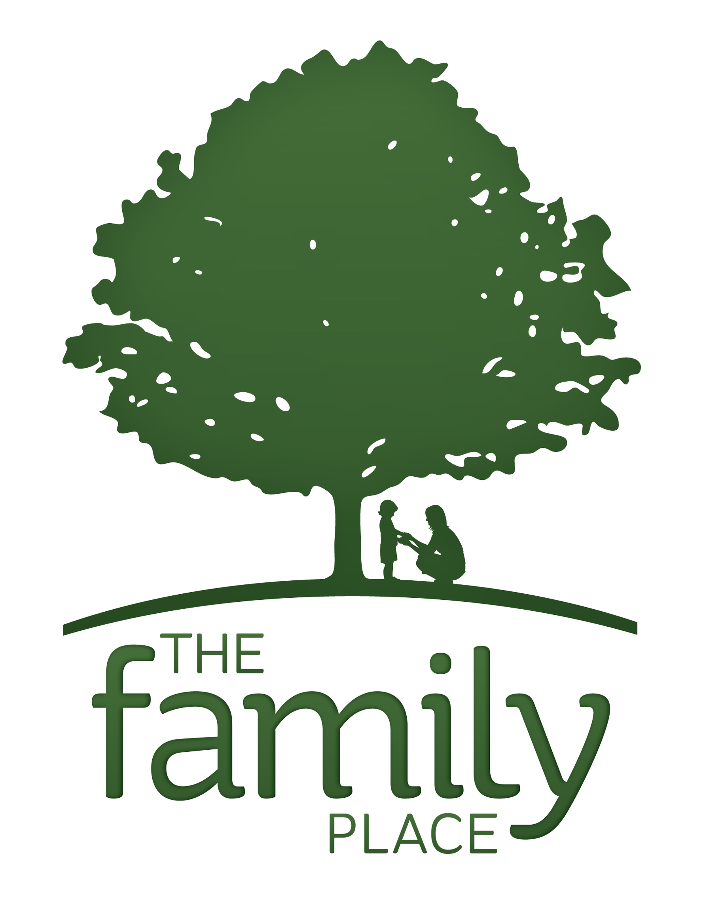

Please return the completed information to The Family Place as soon as you can. Thanks!

IMPORTANT REMINDERS
FOR ALL GINGERBREAD HOUSES:

- House bases should be no larger than 12” x 16”.

- All bases should be made of sturdy material such as plywood or foam board. Remember, houses need to be transported. Bases will be provided if needed; please call The Family Place to make arrangements to pick up your base (802) 649-3268.

- Houses need to be delivered to the Tracy Hall, Norwich on Friday, December 2nd, between 10 AM and 4 PM, unless other arrangements are made.

House designer information:

Name:
Contact:
Address:
Town, State, Zip:
Phone:
Gingerbread House information:
This information will be printed on the auction list and forms.

Creators’ Name(s):

Gingerbread House Name(s): ______

Age of house designer:  under 12 years old  12 and up

Questions or comments:

______________________________________________________________________________

______________________________________________________________________________

THANK YOU FOR CONTRIBUTING A GINGERBREAD HOUSE
TO OUR FESTIVAL!!

